Value Stream Mapping (VSM): Weekly Assignment Workflow
Alex Baldree
June 30, 2026
CSD380

Introduction
For this assignment, I chose to create a value stream map for my weekly school assignment workflow. I picked this example because it is something I do almost every week, and it is a process that can either run smoothly or become stressful depending on how well I plan it. The process starts when the week or module opens and ends when I submit the assignment and check for feedback. By mapping the full workflow, I can see where my time goes, where delays happen, and what steps I can improve.
Value Stream Mapping is useful because it shows the full flow of a process instead of only looking at one task at a time. ASQ describes VSM as a lean tool that uses a flowchart to document each step in a process, identify waste, reduce cycle time, and support process improvement. I used that idea to look at my school workflow as a repeatable process that can be measured and improved.

Current State VSM Graphic
The graphic below shows my current weekly assignment workflow. I broke the work into five main stages: Planning, Preparation, Drafting, Revision, and Submission.
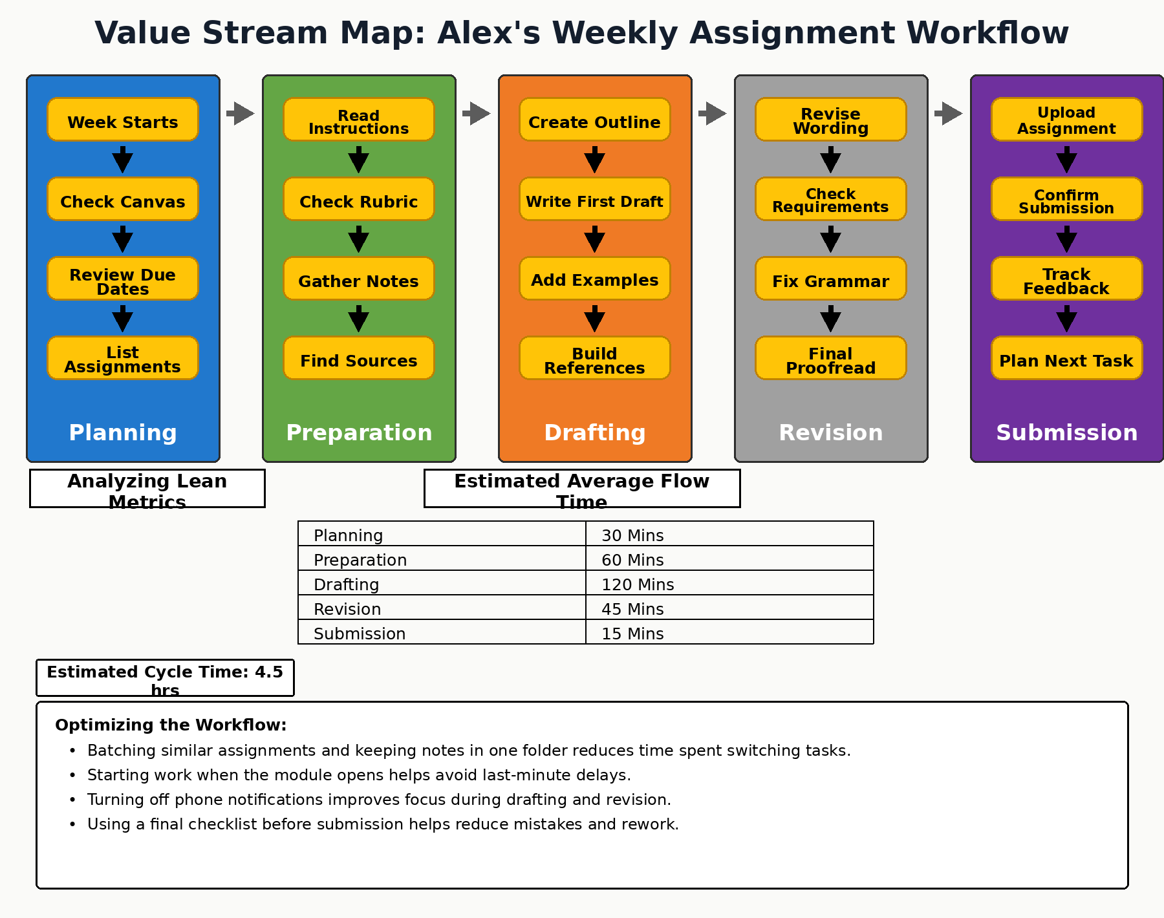
Figure 1. Value Stream Map of my weekly assignment workflow.

Lean Metrics Analysis
The table below shows the estimated average flow time for each stage of my process. These times are based on how long the work usually takes when I stay focused and move through the assignment without long breaks.
Stage | Estimated Time | Main Work Completed
Planning | 30 minutes | Check Canvas, review due dates, and list assignments
Preparation | 60 minutes | Read instructions, check rubric, gather notes, and find sources
Drafting | 120 minutes | Create outline, write first draft, add examples, and build references
Revision | 45 minutes | Revise wording, check requirements, fix grammar, and proofread
Submission | 15 minutes | Upload assignment, confirm submission, track feedback, and plan the next task
Total Estimated Cycle Time: 270 minutes, or about 4.5 hours.
The longest part of the process is drafting, which takes about 120 minutes. That makes drafting the main bottleneck because it is where most of the work happens. This stage includes outlining, writing, adding examples, and building references. Preparation is also a major time area because I sometimes spend extra time looking for notes, finding sources, or rereading the instructions before I feel ready to start.
The main wastes in this process are waiting, searching, task switching, and rework. Waiting happens when I do not start the assignment early and end up pushing it closer to the deadline. Searching happens when my notes, sources, or assignment files are not organized in one place. Task switching happens when I bounce between Canvas, Word, websites, messages, and my phone. Rework happens when I miss a requirement and have to go back to fix something that could have been caught earlier.

Optimization Plan
After reviewing the map, I found several ways to improve the process without changing the assignment itself. The goal is not to rush through the work. The goal is to remove wasted time so I can spend more time on the parts that actually create value, like writing clearly, using good examples, and checking the rubric.
- Start when the module opens so I am not waiting until the deadline is close.
- Keep assignment instructions, notes, drafts, and sources in one folder for each module.
- Use a simple checklist before submitting so I can catch missing requirements earlier.
- Turn off phone notifications during drafting and revision to reduce distractions.
- Batch similar tasks, such as finding all sources at one time instead of stopping during writing to search for them.

Future State Estimate
If I use these improvements consistently, I estimate that I can reduce the process from about 4.5 hours to about 3.5 hours. The biggest improvement would come from reducing preparation and rework. Having my files organized, using a checklist, and starting earlier should lower the amount of time I spend searching, rereading, and fixing missed details.
Stage | Current Estimate | Improved Estimate
Planning | 30 minutes | 20 minutes
Preparation | 60 minutes | 40 minutes
Drafting | 120 minutes | 100 minutes
Revision | 45 minutes | 35 minutes
Submission | 15 minutes | 15 minutes
Total | 270 minutes / 4.5 hours | 210 minutes / 3.5 hours

Conclusion
This VSM helped me see that my weekly assignment workflow is more than just writing the assignment. Planning, preparation, revision, and submission all take time, and small delays in those areas can add up. The most useful change I can make is to organize my work earlier and use a checklist before submitting. That should help me reduce wasted time, lower stress, and turn in assignments with fewer mistakes.

Reference
American Society for Quality. (n.d.). Value Stream Mapping Tutorial - What is VSM? https://asq.org/quality-resources/value-stream-mapping

